Vulnerability Assessment & Penetration Testing
ADVANCED NMAP
High-Port Reconnaissance & Service Banner Grabbing

Report Title | Advanced Nmap — High-Port Reconnaissance & Banner Grabbing
Prepared By | Farhan Shaikh
Course / Track | TuteDude Cybersecurity Track (TryHackMe)
Room | tryhackme.com/jr/tutedude-cybersec
Target Host | 192.168.155.129
Scan Date | 16 August 2026
Report Compiled | 19 August 2026
Status | ✅ Confirmed — Flag Captured

1. Objective
This engagement targets host 192.168.155.129 within the TryHackMe TuteDude Cybersecurity track. The objective is to perform a full-spectrum Nmap reconnaissance sweep, identify every listening TCP service — including non-standard high ports — and recover a flag disclosed through active service banner grabbing.
The exercise reinforces a core recon principle: scanning only the default top-1000 ports is not enough. Services (and, in this case, sensitive data) are frequently relocated to unconventional high ports, and only a complete 0–65535 sweep will reveal them.

2. Scope & Target Information
Target Host | 192.168.155.129
Attacking Host | Windows attack machine (PowerShell)
Tooling | Nmap 7.99
Environment | TryHackMe lab / AttackBox
Authorization | In-scope, authorized TryHackMe training lab only

3. Methodology

3.1 Full TCP Port Enumeration
A complete sweep of all 65,535 TCP ports was run against the target, skipping host-discovery (the box does not reliably answer ICMP) and using aggressive timing for a responsive lab host:
nmap -Pn -p- -T4 192.168.155.129
Flags used:
- -Pn — treat host as online, skip ping discovery
- -p- — scan the full port range (1–65535), not just the default top 1000
- -T4 — aggressive timing template for faster results on a stable lab network
Result: seven open ports were identified, including an unusual high port, 65534/tcp, running an unidentified (“unknown”) service — flagged for deeper inspection.

3.2 Targeted Service Detection & Banner Grab
Port 65534 was re-scanned with version detection and Nmap's banner NSE script, which connects and records whatever the service prints immediately on connection — a fast way to unmask services that leak data pre-authentication:
nmap -Pn -sV --script=banner -p65534 192.168.155.129
Result: the banner script's probes (GenericLines, HTTPOptions, NULL) each returned the same string — the flag itself — straight from the service response, with no authentication or exploitation required.

4. Findings

4.1 Open Port Summary
Port | State | Service
21/tcp | open | ftp
22/tcp | open | ssh
80/tcp | open | http
139/tcp | open | netbios-ssn
445/tcp | open | microsoft-ds
8080/tcp | open | http-proxy
65534/tcp | open | unknown → flag disclosed via banner

4.2 Flag Disclosure Analysis
Port 65534 is a randomized, non-standard high port — the kind of placement often mistaken for a security control. In practice it is not: the service still answers unauthenticated probes, and the banner script proved it by returning the flag on first contact, with no credentials, exploit, or handshake needed.
Raw NSE output (transcribed):
65534/tcp open unknown
| fingerprint-strings:
| GenericLines, HTTPOptions, NULL:
|_ FLAG{HIGH_PORT_RECON_SUCCESS}
|_banner: FLAG{HIGH_PORT_RECON_SUCCESS}

5. Evidence
Figure 1 — full 65,535-port sweep locating the non-standard high port.
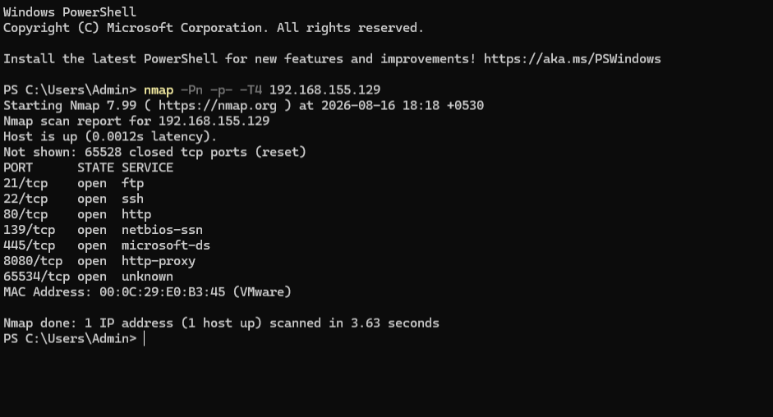
Figure 1: nmap -Pn -p- -T4 192.168.155.129 — full port sweep, port 65534/tcp discovered.
Figure 2 — targeted banner grab on port 65534, flag visible in terminal output.
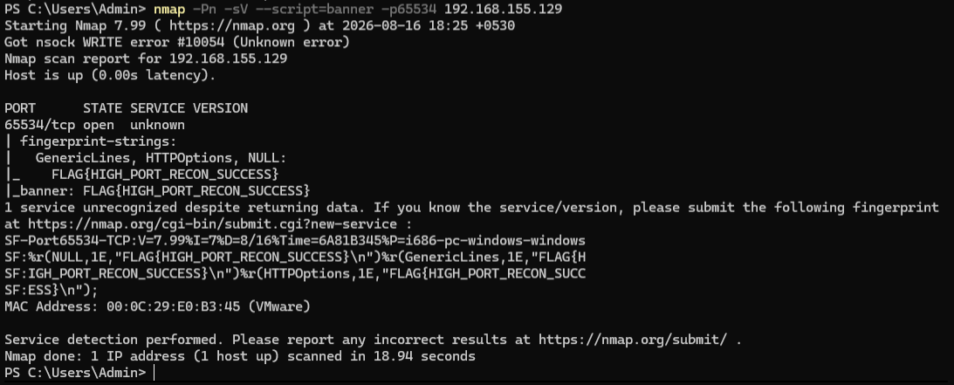
Figure 2: nmap -Pn -sV --script=banner -p65534 192.168.155.129 — flag captured via NSE banner script.
Figure 3 — TryHackMe question answered and verified correct.
Figure 3: TryHackMe room — submitted flag confirmed correct.

6. Security Observations & Recommendations
Although this was a reconnaissance training exercise, the pattern it demonstrates maps directly onto real information-disclosure findings (CWE-200 — exposure of sensitive information to an unauthorized actor):
- Don't rely on high or “random” ports as an obfuscation control — port choice is not authentication. Anything reachable will eventually be found by a full-range scan.
- Disable or strip verbose service banners in production; unauthenticated connections should not receive version strings, hostnames, or other identifying data pre-handshake.
- Scan the full 65,535-port range on both external and internal hosts during routine audits, not just the default top-1000 — attackers certainly will.
- Review the other open services in scope (FTP 21, SMB 445) and disable or firewall any that aren't business-critical to reduce overall attack surface.

7. Conclusion
A complete port sweep followed by a targeted banner grab successfully uncovered a service hidden on a non-standard high port and extracted its flag directly from an unauthenticated response — no exploitation needed, only thorough enumeration.
Finding Status: Confirmed — corroborated by live terminal output (Figures 1–2) and a verified correct-answer submission on the TryHackMe platform (Figure 3).

FLAG CAPTURED ✅
FLAG{HIGH_PORT_RECON_SUCCESS}

